**Data structure lab**

Megha Patel

20124107

File handling

1. Write a program to read content of a file and display it on screen.

#include <stdio.h>

#include <stdlib.h>

int main() {

FILE *fptr;

char c;

fptr = fopen("program.txt", "r");

printf("printing content of program.txt file\n");

c = fgetc(fptr);

while (c != EOF)

{

printf ("%c", c);

c = fgetc(fptr);

}

fclose(fptr);

return 0;

}

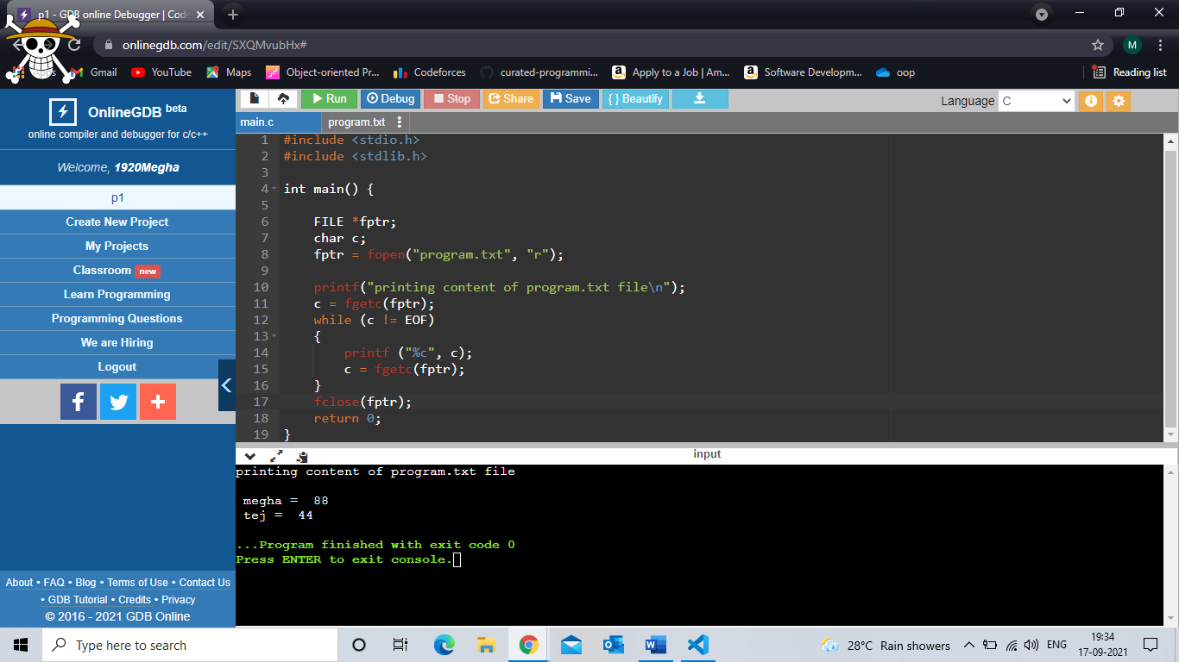

1. Write a program to create a file & write data in it. (To read name and marks of n number of students and store them in a file).

#include <stdio.h>

#include <stdlib.h>

int main() {

FILE *fptr;

int n,i,marks[20];

char name[200];

fptr = fopen("program.txt", "w");

printf("Enter number of student u want enetr:\n");

scanf("%d",&n);

printf("enter name and marks \n");

for(i=0;i<n;i++)

{

scanf("%s ",&name);

fprintf(fptr,"\n %s = ",name);

scanf("%d",&marks[i]);

fprintf(fptr," %d ",marks[i]);

}

if(fptr == NULL)

{

printf("Error!");

exit(1);

}

fclose(fptr);

return 0;

}

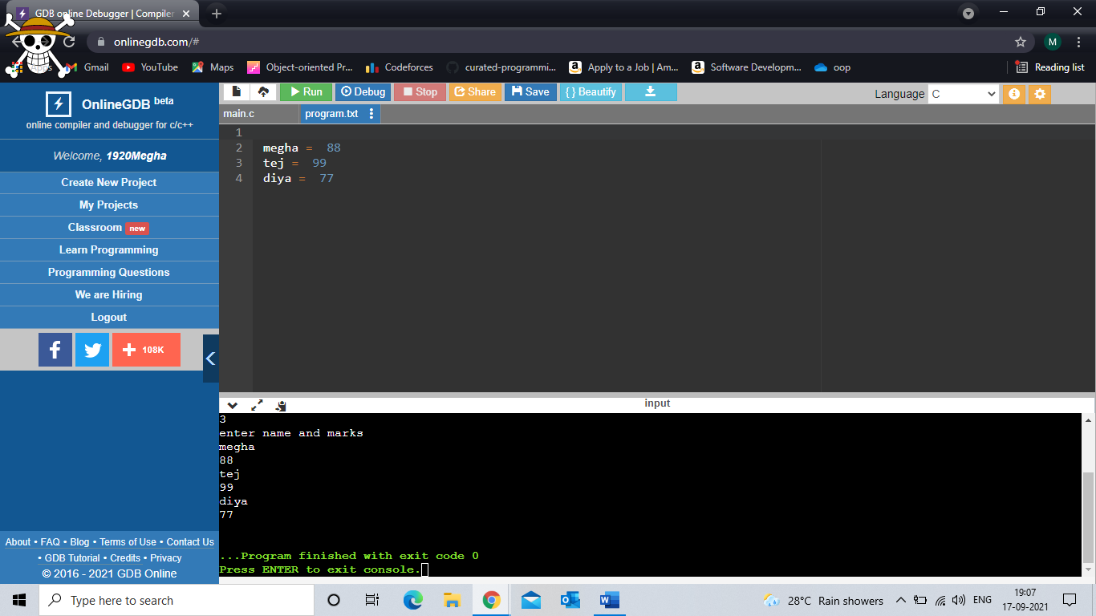

1. Write a C program to reverse the contents of a file.

#include <stdio.h>

#include <stdlib.h>

#include<string.h>

void main()

{

FILE *fptr,*fptr2;

int i,end;

char c,a[]="abcd";

end=strlen(a);

fptr=fopen("p3.txt","r++");

fptr2=fopen("p3.txt","r++");

fprintf(fptr,"%s",a);

c = fgetc(fptr2);

printf ("this is content of file\n\n");

while (c != EOF)

{

printf ("%c", c);

c = fgetc(fptr2);

}

printf("\n\nprinting content of file in reverse file\n\n");

i=0;

while(i<end)

{

i++;

fseek(fptr,-i,SEEK_END);

c=fgetc(fptr);

printf("%c",c);

}

}

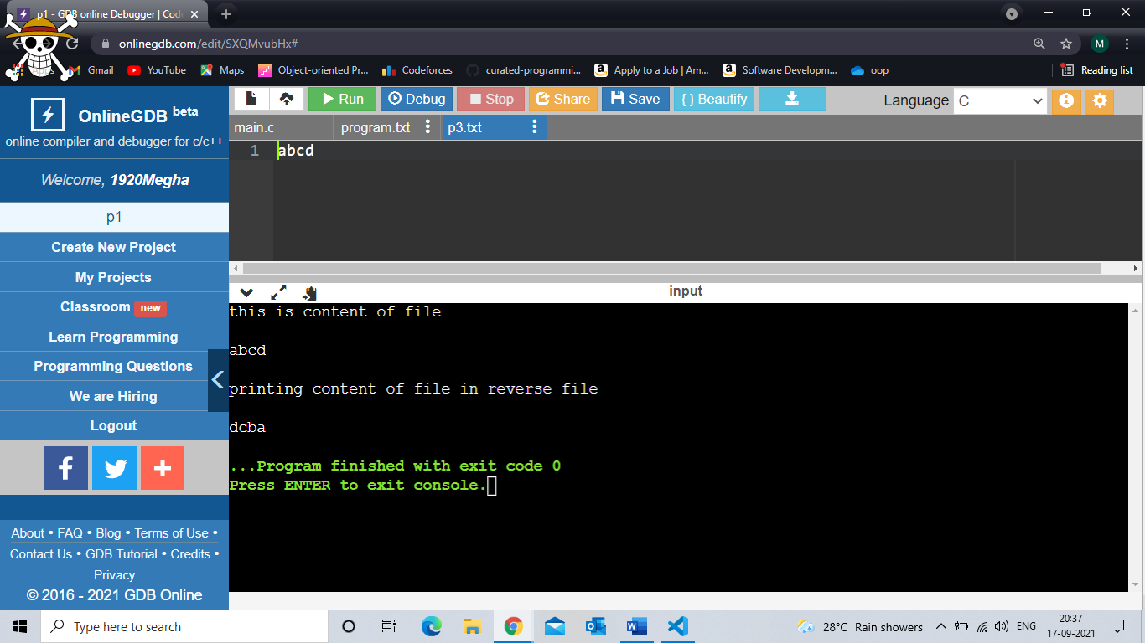

1. Write a C program to copy content of one file into another file.

#include <stdio.h>

#include <stdlib.h> // For exit()

int main()

{

FILE *fptr1, *fptr2;

char filename[100], c;

fptr1 = fopen("program.txt", "r");

if (fptr1 == NULL)

{

printf("error \n";

exit(0);

}

printf("Enter the filename to copy into \n");

scanf("%s", filename);

// Open another file for writing

fptr2 = fopen(filename, "w");

if (fptr2 == NULL)

{

printf("Cannot open file %s \n", filename);

exit(0);

}

// Read contents from file

c = fgetc(fptr1);

while (c != EOF)

{

fputc(c, fptr2);

c = fgetc(fptr1);

}

printf("\nContents copied to %s", filename);

fclose(fptr1);

fclose(fptr2);

return 0;

}

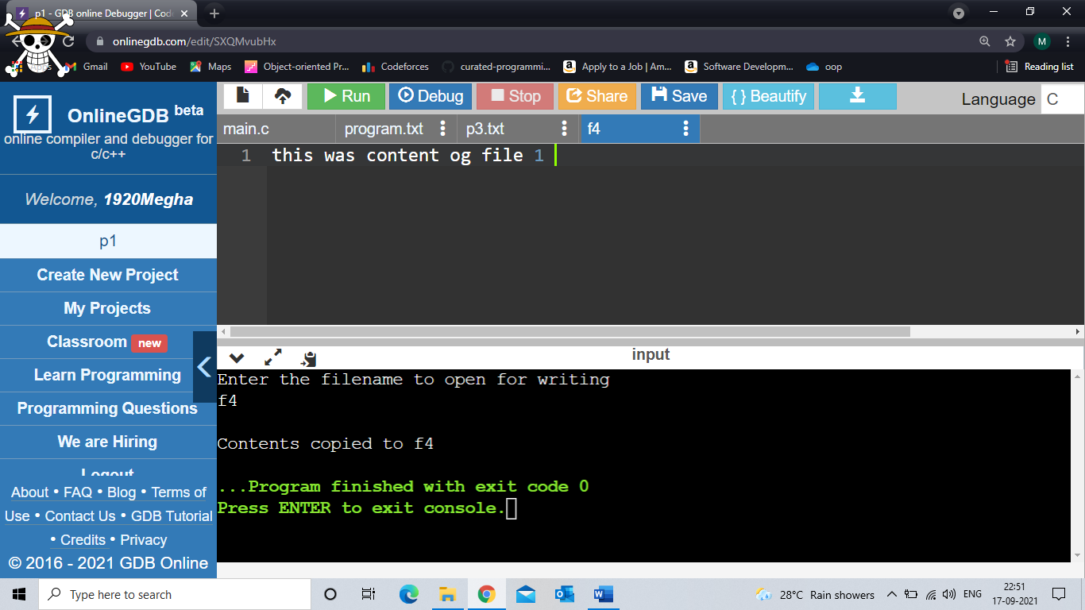

1. Write a C program to write all the members of an array of structure to a file using fwrite (), read the array from the file and display on the screen.

#include<stdio.h>

struct student{

char name[30];

int marks;

};

int main()

{

struct student stud[5],b[5];

char s1[100],s,s2[100],c;

int i,n;

FILE *ptr;

printf("enter no of records you want to enter");

scanf("%d",&n);

ptr=fopen("s1.txt","wb");

for(i=0;i<n;i++)

{

fflush(stdin);

printf("stud name\n");

scanf("%s",stud[i].name);

printf("stud marks\n");

scanf("%d",&stud[i].marks);

}

fwrite(stud,sizeof(stud),1,ptr);

fclose(ptr);

ptr=fopen("s1.txt","r");

fread(b,1,sizeof(b),ptr);

for(i=0;i<n;i++)

{

printf("Name: %s\nmarks: %d\n",b[i].name,b[i].marks);

}

fclose(ptr);

}

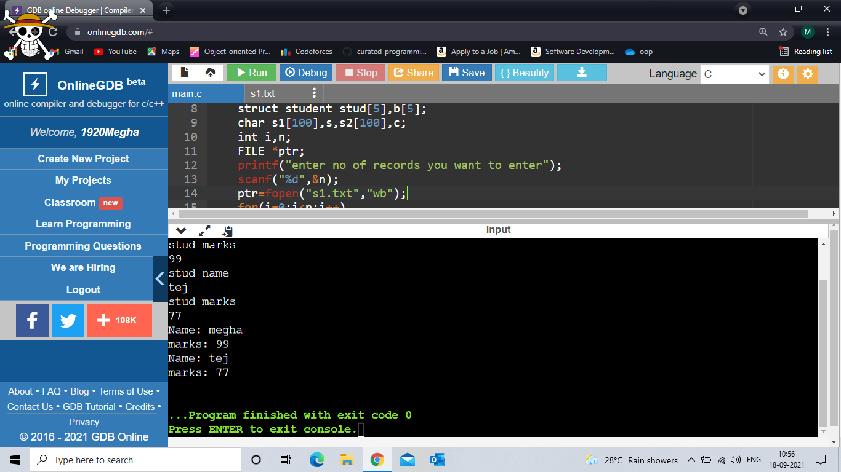

1. Write a C program to find numbers of lines in a file.

#include <stdio.h>

#include <stdlib.h>

int main() {

FILE *fptr,*fptr2;

char c;

int count=0;

fptr = fopen("p5.txt", "w");

fptr2=fopen("p5.txt","r");

fprintf(fptr,"line 1\nline 2\nline 3\nline 4\nline 5");

fclose(fptr);

c=fgetc(fptr2);

while (c!=EOF)

{

if(c=='\n')

{

count++;

}

c=fgetc(fptr2);

}

fclose(fptr2);

printf("p5.txt file has %d lines",count);

}

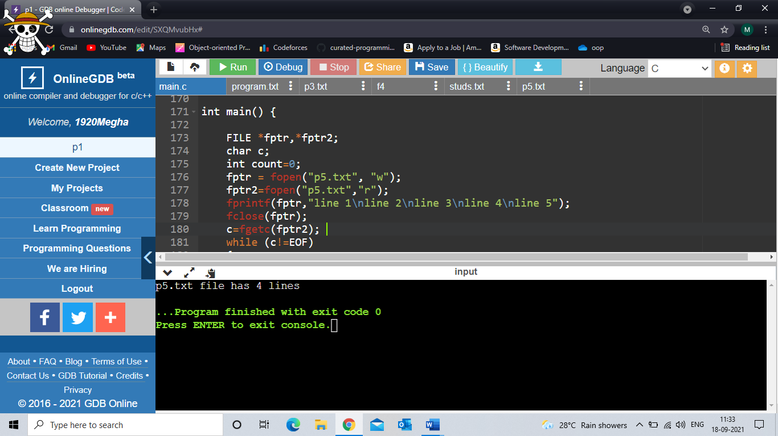

1. Write a C program to convert all characters in upper case of a file. (Use rename () and delete () functions).

#include<stdio.h>

#include<string.h>

int main()

{

char s1[]="program.txt",s2[]="new.txt",c,a;

int i;

FILE *ptr;

rename(s1,s2);

ptr=fopen("new.txt","r");

c=fgetc(ptr);

while(c!=EOF)

{

a=toupper(c);

printf("%c",a);

c=fgetc(ptr);

}

if (remove("new.txt") == 0)

printf("\n\nDeleted successfully");

else

printf("Unable to delete the file");

fclose(ptr);

}

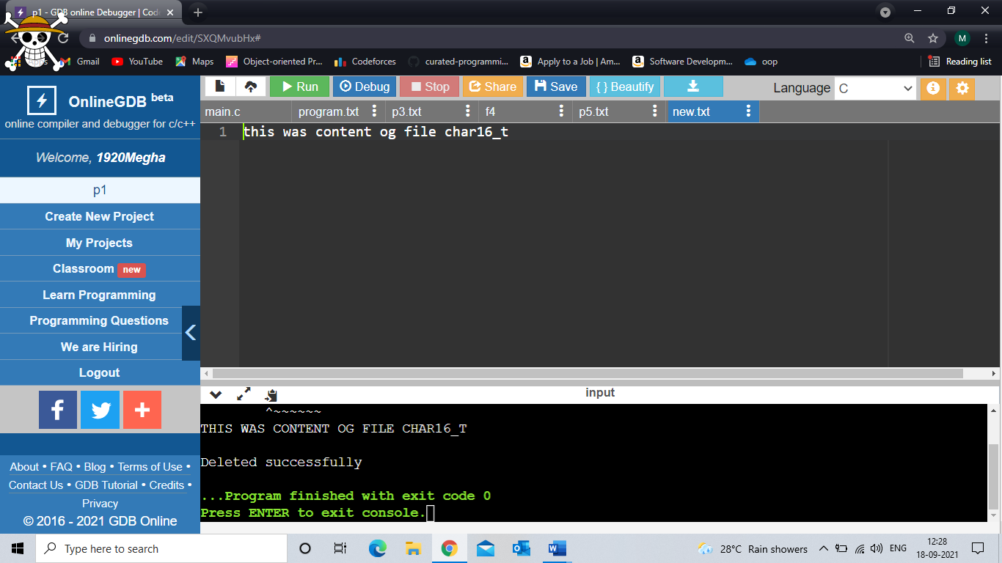

1. Write a C program to append content to a file.

#include<stdio.h>

int main()

{

char s1[100],s,s2[100],c;

int i;

FILE *ptr;

ptr=fopen("program.txt","a");

printf("enter content to append\n");

gets(s2);

fputs(s2,ptr);

fclose(ptr);

ptr=fopen("program.txt","r");

c = fgetc(ptr);

while (c != EOF)

{

printf ("%c", c);

c = fgetc(ptr);

}

fclose(ptr);

}

